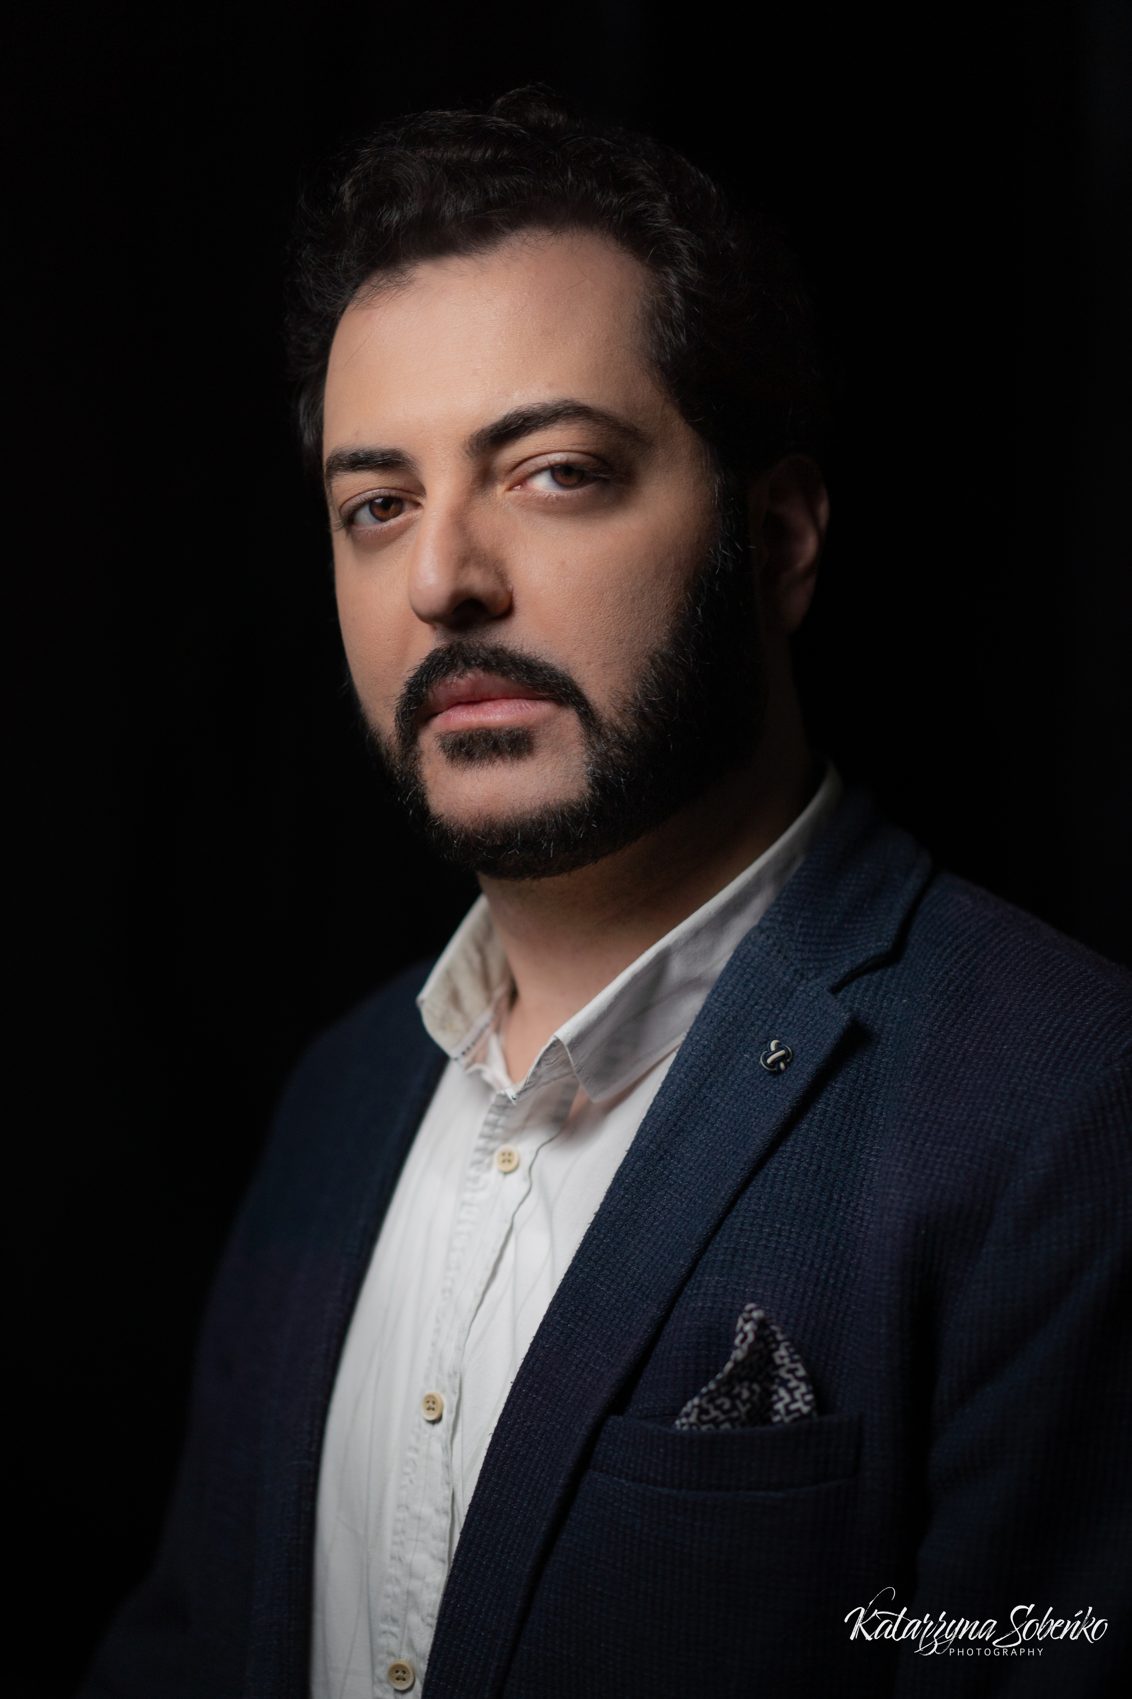

Irakli murjikneli
  - Tenor
  - roles performed
Nemorino L’elisir D’amore Tbilisi State Opera 2017
Vaudemont Iolanta TOBS 2018
Mozart Mozart and Salieri Grand Opera De Tours 2018
Vaudemont Iolanta Grand Opera De Tours 2018
Kote Keto and Kote Tbilisi State Opera 2018
Don Carlo Don Carlo Tbilisi State Opera 2019
Tosca Cavaradossi Tbilisi State Opera 2019
Giovanna D’arco Carlo VII TOBS 2019
Sarka Ctirad TOBS 2020
Tosca Cavaradossi Slovenian National Opera 2021
Oedipus Rex Oedipus Slovenian National Opera 2021
Requiem (Verdi) Tenor Vojvodina Symphony 2021
La Traviata Alfredo Tbilisi State Opera 2021
Faust Faust Slovenian National Opera 2022
La Boheme Rodolfo Tbilisi State Opera 2022
Rigoletto Duca Tbilisi State Opera 2022
Il Trovatore Manrico Opera Na Zamku 2023
Faust Faust Teatr Wielki Lodz 2023
Rodolfo La Boheme Wroclaw Opera 2024
  - education
- 2000-2004 Tbilisi Shota Rustaveli Theater and Cinema State University ( Drama and Film Actor)
- 2005-2009 Tbilisi Vano Sarajishvili State Conservatoire ( Academic Singing Bachelor )
- 2009-2011 Tbilisi Vano Sarajishvili State Conservatoire ( Academic Singing Master )

  - awards
- Second Prize (Giacomo Aragal Prize) International Belcanto Accademy competition Graz Austria 2016
- Orchestra and Opera Prize International Tenor Competition Turnej Tenorow Szczecin Poland 2013
- Finalist of ByulByul Competition 2012
- Diploma Minsk Christmas Competition 2017
- Special Prize for Best Performance of Russian song Elena Obraztsova International competition Saint Petersburg 2015

  - roles prepared
Don Alvaro Verdi La forza del destino
Turidu Mascagni Cavalleria Rusticana
Poleone Bellini Norma

C O N T A C T
Irakli.murjikneli@gmail.com
+995 595281111

www.iraklimurjikneli.com
Tbilisi, Georgia

Language

English Fluent
Russian Fluent
Georgian Native
Italian Basic





